It is the peak of London season, and you are staying at your townhouse, awaiting callers and making calls. Nothing matters more than maintaining your family’s reputation, making a name for yourself, and securing your future. Using Wit, Grace, and Skill, you can outshine your rivals and debut at the top of your station.
Characteristics
Wit is a measure of your conversational ability. It can be used to wound the reputations of your rivals, talk yourself out of tight situations, or charm information out of someone.
Grace is a measure of your poise and how you carry yourself. It can be used to perform a dance or glide across a room and catch the eyes of all around. Grace can also be used to counter Rumours.
Skill encompasses any feats and interests. Arts, music, politics, knowledge of the sciences. Anything you can use to show off and prove how well-born and well-educated you are compared to your peers.
Your character is a well rounded individual, good at some things and less so at others. Assign -1, 0, +1 to your characteristics.
Objective
Each player has the same goal in mind- to finish the event with the highest Reputation. Whether you choose to pursue this goal by flaunting your skills and increasing your Reputation or cutting down your opponents’ Reputation with Rumours and slander is up to you.
Each player starts with a Reputation score of 3. Succeeding on Grace or Skill moves can increase this score and Wit moves can be used to lower another player’s score.

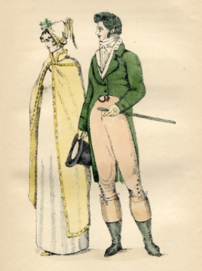
(ID: A Regency fashion plate. )
Gameplay
The game is played in 10 rounds, with each player taking a turn each round. The order can be determined however you choose. Each round, a player chooses an action they want to take- for example, starting a Rumour about another character with Wit, or playing a rousing piano piece with Skill.
Once an action has been decided on, the player rolls 2d6, passing on a score of 7 or above, and failing on a score of 6 or below. A 12+ grants you bonus Reputation. Once per round, a character targeted by a Rumour can contest the antagonizing roll with Grace.
At the end of the game, the Reputation scores are tallied and the player with the highest Reputation is the envy of all. Any characters with Reputation scores of 0 or below are disgraced.
What You Need
- 2 six sided dice (d6)
- 4-6 players (no GM)
- Paper for notes
- A passion for gossip and intrigue

