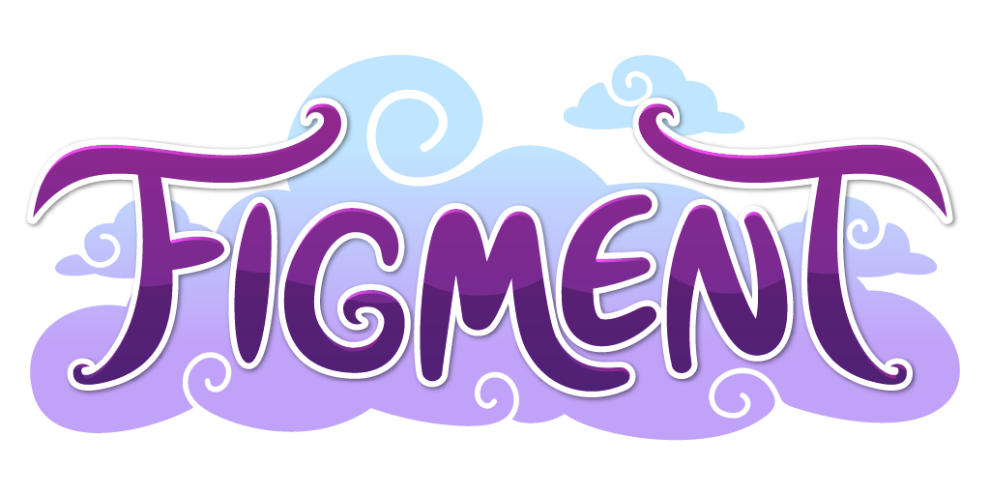
Step 1: Receive your Alpha Key
You must email us to receive this key. It is unique to you.
Email support@figment.pet with this subject: Itch.io BLM

Step 2: Create an Account with Your New Alpha Key
(Click “sign up”)
http://www.figment.pet/
Step 3: Go to the Redeem Code Page
http://www.figment.pet/redeem
Step 4: Your Special Code
202006itchio
Step 5: Enjoy the Game & Your New Rewards!
Questions? Email: support@figment.pet

Join us on Discord!
discord.gg/jW4gVnb

