They won’t go
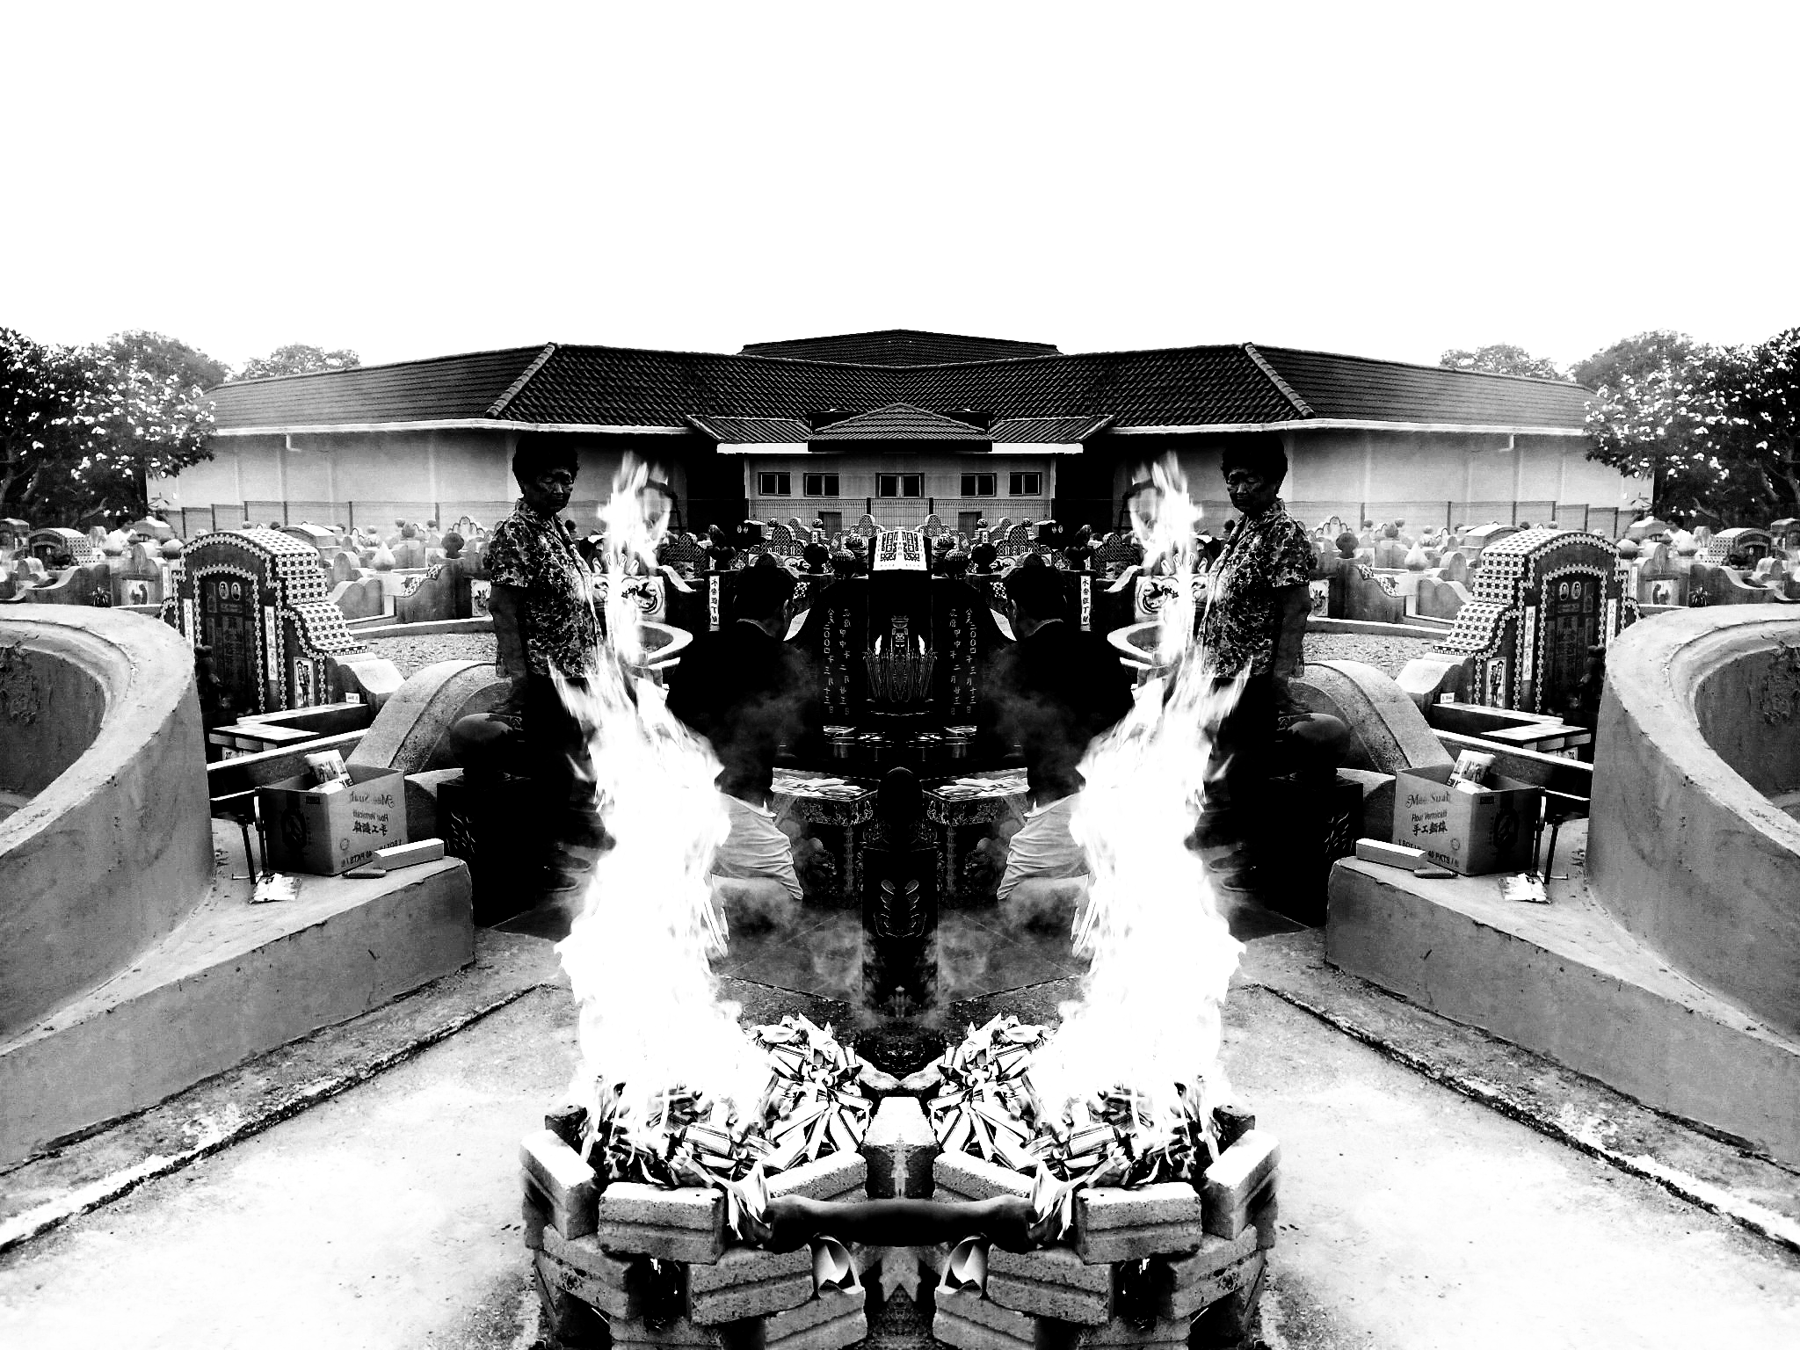
When I go.

A roleplaying game about remembering the dead.
BY BEN CHONG
V. 1.1

“No more lying friends
Wanting tragic ends
Though they do pretend
They won't go when I go”

- Stevie Wonder & Yvonne Lowrene Wright,
‘They Won’t Go When I Go’

~

“What do you think happens to us when we die?”
“...I know that the ones who love us - will miss us.”

- Keanu Reeves to Stephen Colbert,
‘The Late Show with Stephen Colbert’

Glossary

What Is This? | 3
A Word of Caution | 4
Set-Up | 6
How To Play | 7
The Playlist | 9
The Attendance | 11
The Remembering | 12
The Visit | 13
The Final Visit | 13
The End | 14
Acknowledgements | 15

What Is This?

They Won’t Go When I Go is a GM-less tabletop roleplaying game of ritual remembrance, funerals and grave visits for two or more players.

In it, we tell the story of a group of people and their yearly visits to a deceased friend, the Ghost. Every year, they return to perform the traditional grave rites left for them. Every year, something changes.

While playing, we will take on the roles of these Visitors. Over the course of the game, we discover their relationships with the Ghost, confront problems, make decisions and reveal stories. Each one of us will have a unique story to narrate and uncover.

Gather together, visit the deceased, piece together what you can, and complete the rites.
A Word of Caution

As an RPG, They Won’t Go When I Go may have players experience or tackle the following:

- Heavy roleplaying and socialising for an extensive time.
- Intense emotional drama eg. intimacy, anger, sadness etc.
- Death, its consequences and content.
- Personal, traditional, sociocultural practices.

Please take note and make necessary precautions together as players to ensure a healthy, safe game!

Set-Up

They Won’t Go When I Go can be played with 2 players and above.

It does not need a GM to play.

Each session can be played within 1-2 hours.

To play, you will need the following:
- Something to play music eg. smartphone, disc player, etc.
- Printout copies of the Checklist for each player.
- Pen and paper to keep track of details.
- (Optional) Random items and trinkets to be used as props.

They Won’t Go When I Go is best played in a private, enclosed area with plenty of space for the players to move around. A section of the floor should be marked as the ‘grave’ with everyone in agreement.
How To Play

They Won’t When I Go is played in 7 stages:

- The Playlist. Where players submit songs and compile a playlist to be used in the game.

- The Attendance. Where players create characters, and the initial premise and setting of the game.

- The Remembering. Where the Visitors reveal new details about the Ghost and their grave rites.

- The Visit. Where the Visitors gather together for their yearly grave visit.

- The Final Visit. Where the Visitors’ lives and relationships are irreversibly changed. The game ends.

- The End. To discuss between players about the game and debrief its details.

Repeat stage 3 to 5 until there is only one Visitor left, in which the game ends.
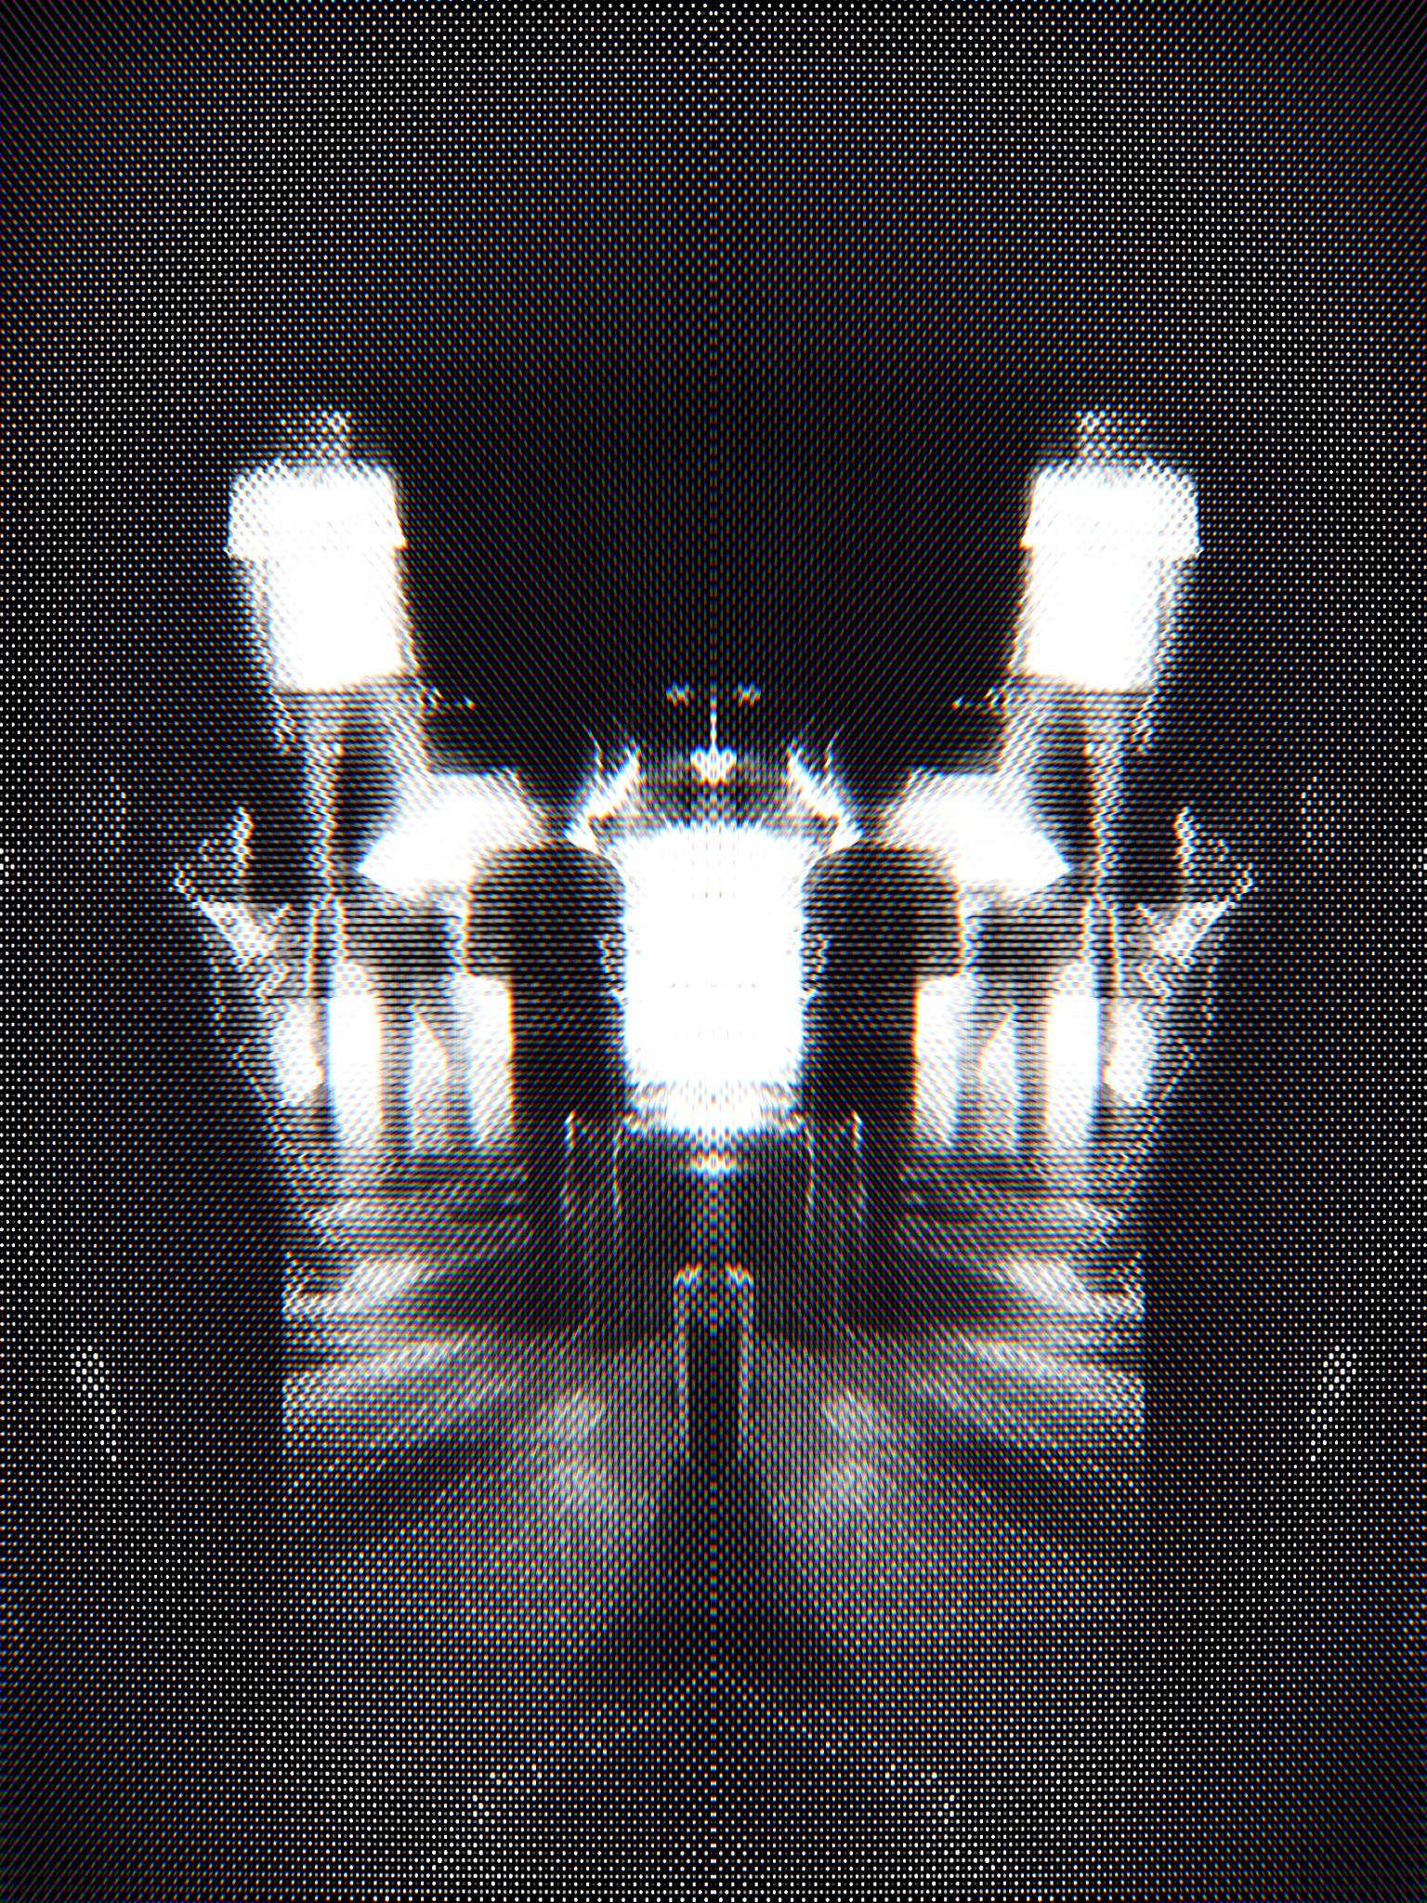
The Playlist

Before we can play the game, the players must work together to compile a Playlist. For each player, they must contribute only 2 songs.

Each song should last for more than 5 minutes unless it’s to play a shorter session.

Once compiled, the playlist will be played randomly on shuffle throughout stages of the game as the players progress together.

Although a theme can help form a more cohesive playlist, the game works best if the playlist is constructed without an aforementioned theme beforehand. It makes for a more interesting and challenging session if a theme arises over time.

The Attendance

In Attendance, the players create their Visitors, build their relationship with the Ghost, and create the initial premise and setting of the game.

First, create a Visitor by using the Checklist printout (below). In one word, each Visitor fills in their:
- Name.
- Relationship with the Ghost before they passed.
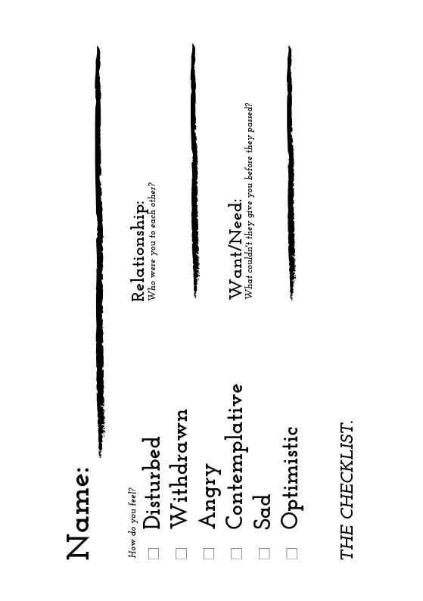
- Want/Need the Ghost could not help fulfill for them before they passed.
Once every player has created a Visitors, they will take turns to introduce their Visitors to each other. The Visitors may only be introduced with name and relationship only - and no other details.

When everyone has introduced their Visitors to each other, they will answer the following questions together:

- What is unique about the world we live in?
- What was strange about the Ghost’s death?
- What did the Ghost leave behind?

All Visitors should agree on the answers together.
Expand on interesting ideas but keep discussions brief.
The Remembering

In Remembering, the Visitors decide the premise of their next upcoming Visit - what will happen, what problems may arise, etc. The Visitors will also build and add new details to the Ghost’s grave rites.

First, the Visitors randomly queue the Playlist for its first or next song on shuffle.

The Visitors then listen to the song together until it ends.

Once the song has ended, the Visitors discuss and answer the following together:
- What is on everyone’s mind for the next Visit?
- What is a problem that will inevitably happen in the next Visit?
- What is a new step in the Ghost’s grave rites?

The Visitors must answer based on the song which was played - its title, lyrics, sound or emotion. Each answer must involve at least one Visitor.

Discuss with each other the most interesting scenarios you could explore or play out together during the next Visit.
The Visit

In the Visit, the Visitors attend their yearly grave visit for the Ghost. While visiting the grave, each Visitor may:
- Take their turn to perform the grave rites;
- Speak with the Ghost at their grave, or interact with the grave;
- Speak with other Visitors at the visit;
- Cause a problem at the visit.

There are no hard rules for what can and cannot be done during the visit, within reason. It is up to the Visitors themselves to ensure everyone performs the rites carefully or recklessly. Visitors may add to the rites with their own preferences.

Visitors are encouraged to check on each other and interact during this stage.

The visit ends only when everyone has taken a turn at performing their rites, and the problem has occured. Every Visitor marks on their Checklist a prominent emotion they felt during the Visit.

The Visitor whose song the current Visit is based on will mark off two emotions instead of one on their Checklist.

The Final Visit

The Final Visit occurs either when a Visitor:
- Has both their songs from the Playlist come up.
- Has all their emotions crossed out on the Checklist.

When this happens, the Visitor Want/Need is finally fulfilled. The Visitor achieves a form of closure or satisfaction without needing to rely on the Ghost’s presence in life anymore.

On their next visit, the Visitor immediately takes their turn to perform the grave rite for the Ghost - their final one. The Visitor informs the Ghost how they finally got what they wanted/needed without them. Once their final rite is done, the Visitor leaves the visit immediately.

All Visitors who perform a final visit are taken out from the game permanently and do not return.

Over the course of the game, the final Visitor will not fulfill their Want/Need. Instead of performing a final rite, they perform the rite as usual and must explain for the Ghost why they are the only Visitor.
The End

Discuss with each other what happens to each Visitor after the Final Rite. Give yourself an epilogue.

How did everyone feel while playing the game?

What does everyone think about the rites? Were they properly done?

Will anyone return for next year’s grave visit? Why not?



Acknowledgements
To Samwise, Sin, Jammi, Jeeyon and the #RPGSEA crew, thank you for the inspirations and support to make so many cool things.

To Arthur, thank you so much for making #FolkloreJam possible, being a wonderful host and letting me become a part of it. It was a pleasure co-hosting it with you.

To everyone else who participated in #FolkloreJam, you are all wonderful and incredible with what you’ve made.

They Won’t Go When I Go
Copyright © 2019 by Ben Chong
@swordsnflowers • swords-and-flowers.itch.io

Made for Folklore Jam 2019.

